**Brooklyn torah gazette**

**For yom tov shavuos 5780**

Volume 4, Issue 34 (Whole Number 186) 6-7 Shavuos 5780/ May 29-30, 2020

**Printed L’illuy nishmas Nechama bas R’ Noach, a”h**

**Rabbi Berel Wein on Shavuos – The Book of Ruth -**

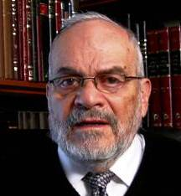

Every biblical narrative has at its heart a main character, a hero or heroine. Even though the book and the scroll of Ruth is named for her, the true main character and heroine of the story is Naomi. This is confirmed in the book itself when the prophet Samuel, the author of the book, relates that when Ruth gave birth to Oved, the women of Bethlehem declared; “A male child has been born to Naomi.”

It is obvious that they did not mean this literally, for Naomi was widowed and no longer of child-bearing age. Nevertheless, the wise women of the town recognized that if it were not for Naomi, Ruth would never have met Boaz in a matrimonial relationship. It was Naomi who planned the entire series of events that

would lead to the birth of this child and the beginning of the dynastic monarchy of the Jewish people.

The book instructs us not to view things in a superficial manner but rather to analyze and understand the causes and circumstances that eventually lead to the details of the narrative. The whole linchpin of the story is the steadfast commitment of Naomi, and her determination not to be crushed by the tragedies that engulfed her. Because of her, there can be a Ruth, a Boaz and eventually, a King David.

Life is oftentimes very difficult, and its burdens can be crushing. For many of us, we are passing through such a time currently. Everything that was familiar, and in fact taken for granted, has been struck from our daily lives. Our future is certainly murky and mysterious. Because of this, strength of character and an iron will to persevere and overcome is vitally necessary.

Naomi is the symbol of these strengths that we desire for ourselves and our community. It is her resourcefulness and true understanding of human nature that will stand us in good stead in our hour of difficulty and adjustment that is upon us. The challenge is how to summon up these characteristics and apply them to our own lives.

In this we can also be instructed by Ruth herself. Her selfless devotion to Naomi even though it meant the forsaking of everything she had known, and of her worldly positions, became her strongest asset. Her commitment was complete and boundless. Her determination not to abandon Naomi, and the faith and tradition of Naomi, became the turning point in her life and brought her to unimagined glory and success. Sometimes in life, forsaking everything becomes the key to acquiring greater things. Judaism teaches that we are measured not by what we take and acquire but by what we give, donate, and forsake.

This is a difficult lesson to put into practice since it runs counter to much of our innate nature, but both Naomi and Ruth rise to greatness on the basis of what they were willing to give up for a higher and nobler goal in life. One has to be willing to humble oneself and to sit amongst the gleaners of fallen grain in order to become, eventually, the matriarch of Jewish eternal monarchy.

*Reprinted from this week’s website of Rabbiwein.com*

**Yom Tov Shavuos**

**The Giving of the Torah – the**

**Ultimate System of Self-Protection**

By Rabbi Bentzion Shafier

Founder of TheSmuz.com

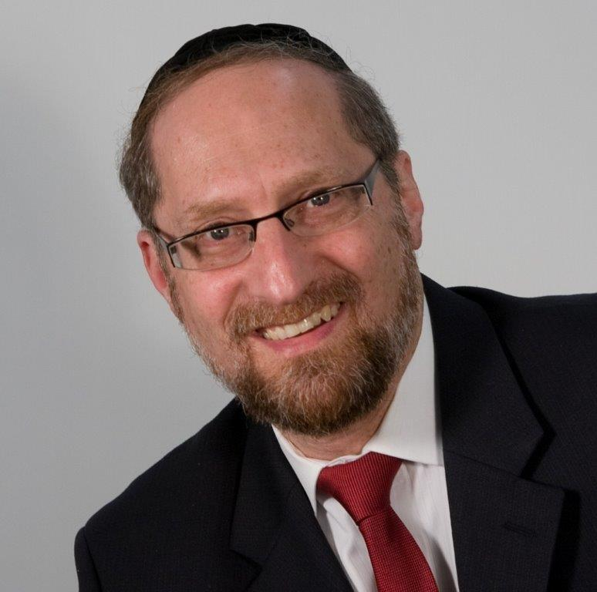

“*Do not covet the house of your neighbor. Do not covet the wife of your neighbor; his slave and maid servant, his ox, his donkey, and all that belongs to your neighbor*.” – Shemos 20:14

The Even Ezra explains that people are perplexed by this mitzvah. How is it possible not to desire that which I find beautiful? The Torah can forbid actions or of speech, because I can to control my behaviors. But desires dwells deep within a person. They are a function of the inner condition. I didn’t ask for them, but they are here. How can the Torah command me not to want?

The Even Ezra answers with a moshol. Imagine, he says, that a simple villager were to see a princess passing in a procession. He may find her very beautiful, but he would never fantasize about marrying her. She is so far removed from his social status that the idea of taking her as a wife is out of the realm of the possible. He wouldn’t even dream about it. If the idea would ever cross his mind, he would quickly rebuke himself, saying, “Am I insane? Do I dream about sprouting wings and flying?”

So too, the Even Ezra explains, when a person understands that HASHEM runs the world and sets forth the right woman for the right man, he will never desire that which isn’t his because he knows that it is impossible for him to have it. It is so impossible that it would be akin to a sane individual dreaming about growing wings and flying.

The Even Ezra is teaching us a fundamental concept in growth: that we can shape our very reality.

**Changing Standards of Beauty**

As an example: there was a time in history when being overweight was considered a sign of dignity. For millennium, people barely had enough to eat. The only ones who could afford enough food to be heavy were the wealthy. As a result, if a man was corpulent, it was a sign of wealth and distinction. For that reason, in many cultures it was considered a sign of beauty for a woman to be heavy. A woman of distinction was large, and the larger, the more distinguished.

That isn’t our reality today. Rather than utter those dreaded words, “She is overweight,” a shadchan will use fifteen euphemisms. “I mean she is average.” “She has wonderful middos, a special chen, great yichus. . . ” Anything to avoid saying that the young woman is heavy.

Why is that we now loathe what many societies once considered desirous? The reason is that beauty is a function of perception. Young men are cultured, often from a very young age, that a certain standard is appealing. That is the desired state. That is how their sisters look, that is how they mothers rate attractiveness and beauty, and their reality is shaped by what others accept as the standard.

The point is that what is considered attractive is not hard-wired at birth; it is learned, often shaped by what others consider desirable. By nature the human desires, but the object of his desire is shaped by external factors and perceptions.

This seems to be the point that the Even Ezra is sharing with us: that we can shape our very reality. That which I desire will only be within a specific range of things, and it must be possible to be had. If I were to focus on the fact that HASHEM truly is in charge, I would understand that it is literally impossible to for me to have the life situation that my friend has. His money, his job, his house, and his wife were all set by HASHEM – and there is nothing in my power to change that. Once I comprehend this, my desire for the object begins to wane. It enters into the realm of the impossible. It will just never happen. And so, I no longer desire it. Much like the villager would never dream of sprouting wings to fly, it’s insane.

When I stop desiring what others have, I also attain a state of peace, tranquility, and happiness with the lot that HASHEM has chosen for me. I understand that HASHEM knows better than I what it is that I need, and HASHEM has chosen for me the exact life setting and circumstances that are best for me.

Rabbi Ben Tzion Shafier, is the director of Tiferes Bnai Torah and The Shmuz

Reprinted from this week’s website on TheShmuz.com This is an excerpt from the *[Shmuz on the Parsha book](https://theshmuz.com/product/shmuz-on-the-parsha-book/)*.

**How to be Happy and Free**

* ***A Shavuot Message -***

**From the Letters of the Lubavitcher Rebbe**

**Rabbi Menachem Mendel Schneerson, Zt”l**

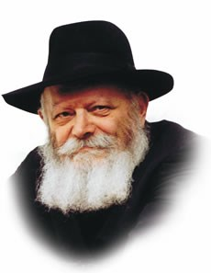

*(Editors note: The Rebbe, of righteous memory, would periodically issue a pastoral letter in preparation for the Shavuot holiday. Below we bring you one such message addressed to youth.)*

***

Dear Friend,

Following Pesach — the Festival of Our Liberation — comes Shavuot — the Festival of the Receiving of Our Torah. The days of *Sefirah* (Counting of the *Omer*), beginning immediately on the morrow of the first day of Pesach and ending on the eve of Shavuot, connect these two great festivals.

Many significant lessons can be learned from this, of which I will point out but one:

Our Sages tell us that when Moshe was about to lead the children of Israel out of Egypt, he told them of G‑d's promise to give the Torah to His beloved people following their liberation from bondage. At once they asked when would that happy day be, and Moshe replied that it would be fifty days later.

Every day the children of Israel counted: One day is gone, two days, three, and so on, and eagerly looked forward to the fiftieth day. The children of Israel understood that there could be no real freedom — freedom from any fear of oppression by others, and freedom from one's own evil inclinations — except through laws of justice and righteousness, which only the Creator of all mankind could make, because

He knows best what is good for them. It is not surprising, therefore, that they were so eager to receive the Divine Torah, containing those wonderful laws to guide them and all the world.

Let us also remember that we cannot be truly free men, nor would we be worthy of such freedom, unless we take upon ourselves to observe and do all that G‑d commanded us in His holy Torah. Like our ancestors at Mount Sinai, we also must proclaim: *Naaseh vnishmah* — we will do and learn; and only then will we have lasting freedom.

Indeed, it was their determination, while still in Egypt, to accept the Torah that merited them their liberation from enslavement. Likewise at this time, our return to the Torah and its observance, while awaiting for the Redemption, will hasten the coming of Mashiach and merit us the true and complete Redemption in our own day.

Wishing you a happy Shavuot,

Rabbi Menachem M. Schneerson

*Reprinted from the Shavuot website of Chabad.Org*

**Shavuot – Yes, the**

**Torah is For Us**

**By Rabbi Eli J. Mansour**

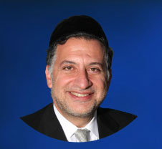P

The Mishna in Pirkeh Abot (3:14) teaches, "Man is precious, in that he was created in the image [of G-d]… Yisrael are precious, in that they were called children of the Almighty… Yisrael are precious in that they were given a beloved vessel [the Torah]…"

For each of these three statements, the Mishna brings a verse to prove the point being made. The statement that people are created in G-d’s image is supported by the verse, "for He made man in the image of G-d" (Bereshit 9:6). The statement that Am Yisrael are G-d’s children is supported from the verse, "You are children of Hashem your G-d" (Devarim 14:1). And the statement that we have been given a "beloved utensil" is supported with the verse in Mishleh (4:2), "For I have given you good teaching; do not abandon My Torah."

**For What Purpose are We Told that We are Precious?**

The Netivot Shalom (Rav Shalom Noach Berezovsky of Slonim, 1911-2000) raised the simple question of why this Mishna is included in Pirkeh Avot, which is a collection of practical ethical and religious teachings. The Mishnayot in Pirkeh Abot give us instructions and guidance for living our lives as Torah Jews. For what purpose are we told in Pirkeh Avot that we are "precious" both because we are human beings and because we are members of Am Yisrael?

The answer, the Netivot Shalom explains, is that this Mishna seeks to bolster our self-esteem, and reassure us that we are "precious" in the eyes of G-d. One of the common obstacles to religious commitment is shame and a lack of self-worth. Many people look at themselves, their behavior and their lives and conclude that G-d has no interest in them, that the sanctity of the Torah has no relevance to them. The Mishna therefore comes along and assures us that no matter who we are and what we have done, we are "Habib" – "precious," both because we are human beings endowed with the divine image, and because we, as Jews, are princes, the children of the King of the world.

**The Basis on Why the Mishna Chose These Three Verses**

The Netivot Shalom explains on this basis why the Mishna chose specifically the three verses it cited.

The verse, "for He made man in the image of G-d" actually appears in the context of the prohibition of murder. G-d warns that one who murders another person will himself be killed, because every person is endowed with the image of G-d.

The Mishna chose this verse, the Netivot Shalom explains, because this verse makes it absolutely clear that every human being, for all time, has the image of G-d within him, and it can never be lost. If a person murders somebody else, he is liable to the death penalty regardless of who the victim was – because all people have a sacred spark within their souls, no matter what mistakes they have made.

The second verse cited by the Mishna – "You are children of Hashem your G-d" – introduces the prohibition against self-mutilation in response to personal tragedy ("Lo Titgodedu"). The Mishna could have cited an earlier verse to prove that Am Yisrael are Hashem’s children – G-d’s message to Pharaoh, "Yisrael is My firstborn son" (Shemot 4:22).

**A Command that is Eternally Binding**

It didn’t cite that verse, the Netivot Shalom writes, because one might have then assumed that only in those times, when G-d brought Beneh Yisrael from Egypt, we had the status of His beloved children. And so the Mishna cited the verse, "You are children of Hashem your G-d" which introduces a command which is eternally binding. This verse demonstrates that for all time, and under all circumstances, we are the Almighty’s beloved children.

Finally, the Mishna proves that we are precious by virtue of our having been given the priceless gift of the Torah, citing the verse, "For I have given you good teaching; do not abandon My Torah." This verse speaks to each and every person, in each and every era, assuring him that the Torah has been given to him, it is relevant to him, and it is binding upon him.

Each morning, we recite a special Beracha – "Birkat Ha’Torah" – thanking Hashem for giving us the Torah. This Beracha concludes, "Baruch Ata Hashem Noten He’Torah" – "Blessed are You, Hashem, who gives the Torah." This Beracha is formulated in the present tense – "who gives the Torah" – because the Torah is given to us anew, each and every day, no matter what situation we are in, and no matter what spiritual level we are on.

**Something to Reflect Upon as We Prepare for Shabuot**

This is something to reflect upon as we prepare for Shabuot, when we celebrate Matan Torah. It is a mistake to think that Matan Torah was relevant only to previous generations, when Jews lived on a higher level, when they did not have the distractions and temptations that we face in our time.

This is incorrect. We must remind ourselves that the Torah is for us – yes, even us. Let us not belittle ourselves. As the Mishna teaches us, we are G-d’s beloved children, eternally. He wants us to serve Him and to build a relationship with Him to the best of our ability, no matter what we have done in the past.

The Gemara relates that when the Romans entered the Bet Ha’mikdash, just before they set the building ablaze, they entered the Kodesh Ha’kodashim – the most sacred chamber, where the Aron was kept – and they saw the two Kerubim (cherubs) on top of the Aron embracing one another.

**Symbolizing G-d’s Embrace of the Jewish People**

This symbolized G-d’s embracing the Jewish People. Even at that moment, when G-d was angry at His nation and destroyed the Mikdash, He showed us how much He loves us. G-d’s love for us is eternal and unconditional, and so our commitment to Torah must be eternal and unconditional.

Yes, the Torah is for us, on whatever level we are on, because no matter what, Hashem wants us to have this most precious of all gifts – the sacred Torah.

*Reprinted from this week’s website of the Edmond J. Safra Synagogue in* Brooklyn.

**Why Would They Say No**

**By Rabbi Moshe Levy**

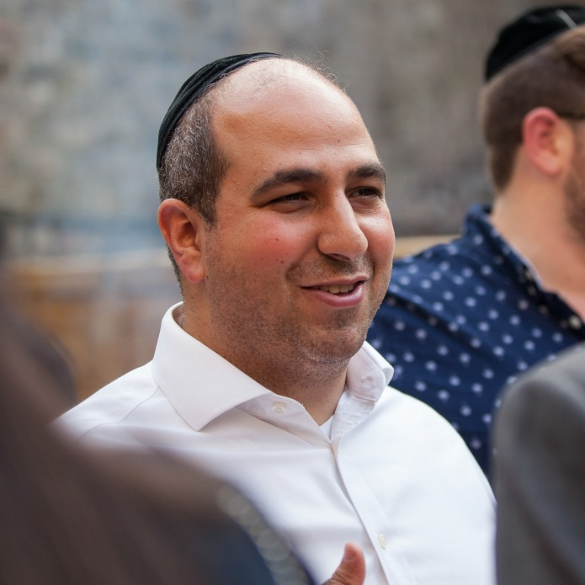

Our Chachamim tell us that before Hashem gave us the Torah, He went to the other nations and offered it to them. They very logically asked “What’s inside this Torah You are offering us?”

Hashem replied “Don’t kill, don’t steal and don’t commit adultery.”

“No thank you” they all answered.

Is there a civilised society in the world where it is ok to kill, steal or commit adultery? If Hashem would have said to them “You need to keep kosher and Shabbat, etc.”, I could understand their apprehension. However to keep things they are already doing, that constitute the fabric of a functioning society, makes no sense to reject.

One of the main questions asked of me as a Rabbi is “I am a good person - why is that not enough”?

I often respond “ Well, what makes you a good person?

“The inevitable answer almost always is “ I give charity and help old people.”

Those are of course both mitzvot from the Torah.

“What else?” I ask, to which people often don’t really have much to add to their original response. The majority of values in the wider world are based on the teachings of the Torah, but not all of them.

When you look at the world today compared to 50 or 100 years ago, it is a very very different place. What was considered ethical and moral then, seems outdated, old-school and sometimes even crazy in the present day. The type of language which was used then and the modesty in which the average person dressed in public, then compared to now represents two different worlds.

When the nations told Hashem “We don’t want the Torah You are offering”, what they were actually saying was “We don’t want You to decide for us what is ethical and moral. We will decide what is murder, as You might tell us that abortion is murder, but we have decided it is ok. You might tell us that certain situations are stealing while we think it is isn’t.”

President Obama in his inauguration speech said “Our challenges may be new. The instruments with which we meet them may be new. But those values upon which our success depends -- honesty and hard work, courage and fair play, tolerance and curiosity, loyalty and patriotism -- these things are old. These things are true. They have been the quiet force of progress throughout our history.”

I think that we as Jews in 2020 can say the same exact thing about Torah. We live in a world that is constantly changing but our principles need to be the identical to those 100 and 1000 years ago. We do not try to live in the past; but we need to make sure we don’t get caught up in the ever changing views and values of society. If we do then, before we know it, we will have a different religion than the one we were blessed from Hashem with, three thousand three hundred and thirty two years ago.

A few years ago, I was on a plane to Israel seated next to a man named Paul. When I asked him his occupation, he told me that he is the chairman of a reform and liberal rabbinical institution. When he asked me what I do, I replied I am an orthodox Rabbi teaching and.... We both could not help but smile as to how Hashem had put us next to each other.

We got schmoozing, eventually talking about what it means to be a Jew. Paul said that he believes that Judaism is all about being a good person and doing the right thing. I told him I agree 100%.

He got a big grin and responded “My 86-year-old motherin-law loves to go to shul; the only way she can get there is to drive. Isn’t it right that she should be able to get to shul and pray to Hashem?”

Wouldn’t you say that is the right thing to do? I answered him that in theory that sounds very good. The problem is that when one person comes and says to me “I am quite poor. I live next door to a KFC which is happy to give me the leftovers late at night. Isn’t it right that I should be able to eat well at no cost, even if it is not kosher?”

Another person might say “I am forty years old, have been dating for years, and have fallen in love with a person at work. Isn’t it right I should be able to get married to someone who loves me while I can still have children, even if that person is not Jewish?”

Someone else tells me he has a friend who works at Hugo Boss. He gives him suits which happen to have wool and linen together. Isn’t it right that he would be able to wear a new amazing suit even if there is shatnez?

If each person starts to decide what is right and what is wrong, then we will have a million versions of Judaism and ultimately no Judaism. Sure it sounds logical that we should be able to drive when we want, eat what we want and wear what we want; but the line and boundaries of what is ok and what isn’t ok keeps changing with each generation.

When we accepted the Torah we were telling Hashem “We are letting You decide for us what is right and what is wrong, what is ethical and what is moral.” We are good people whose virtuous actions emanate from the Torah. Just being a good person is not enough. I might think it is enough and you might think it is enough, but Hashem in His infinite wisdom knows that we need to do more.

It does not matter what we think; it only matters what Hashem thinks. We need to keep it in the fold: keep Shabbat, kosher shatnez, and more, even if we do not understand why. I trust and know that Hashem does.

The nations told Hashem “No” so they could do what they wanted, justifying it by saying that in today’s day and age, this is the norm. The Torah is our guiding compass on how to live life always, especially today in a world that often seems so crazy. Torah is our instruction manual in our generation where what is right and what is wrong is so complicated. Torah is more relevant now than ever before.

*Reprinted from the Parshat Bamidbar 5780 email of Oneg Shabbos (London, U.K.) Rabbi Levy is the executive director of Chazak, U.K.*

**Enlighten Our Eyes**

**By Rabbi Yehudah Yona Rubinstein**

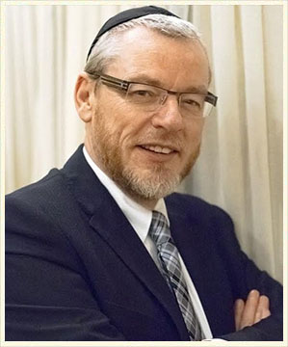

Benny Rubinstein, a man in his 30s, has keratoconus, a serious eye condition that causes the cornea to distort unevenly. With double vision, he could need a cornea transplant before the age of forty, but there is a ten year waiting list. Many doctors told him that it was only a matter of time before he would go blind.

Benny is a photographer. His eyesight is his livelihood. One day, Benny was flying from Manchester to Israel to photograph a wedding. His first flight, which had a stopover in Berlin was cancelled and he immediately purchased a ticket for the next direct flight from Manchester.

He boarded the plane and sat down in a seat in the last row. To his surprise, the flight attendant approached him and asked if he would like to be upgraded to first class. Benny enthusiastically agreed. As soon as he sat down in his plush new seat, the man sitting next to him introduced himself as Andrew Fink, an ophthalmologist from Manchester.

After a few minutes of conversation, Dr. Fink discovered that Benny was originally from Gateshead. “I studied medicine at the University of Newcastle,” Dr. Fink said, “So I’m familiar with Gateshead.”

Staring at Benny’s kippah, he continued, “When I was a medical student, there was a rabbi from Gateshead who came to the university to teach us Torah. Do you by any chance know Rabbi YY Rubinstein?”

Benny couldn’t believe it.

“He’s my father,” he proudly replied.

Dr. Fink was in complete shock. “Incredible! I loved your father’s classes.” Benny told Dr. Fink some of his medical history. “I have keratoconus and the prognosis is not good.”

Dr. Fink asked several questions, listened patiently and finally said, “Your doctors are wrong! A new procedure was developed in the United States and has been recently approved by the Israeli Health Ministry. It will heal your eyes.” Benny was stunned, but Dr. Fink wasn’t done yet. “Your father impacted my life tremendously and I am forever grateful. I want to perform this procedure for you for free.”

Several weeks later, Dr. Fink performed the procedure and restored Benny’s eyesight. His sight has remained stable ever since. In addition to his photography, Benny digitizes Talmudic scripts that are learned by thousands of Torah scholars worldwide.

In our morning prayers, we ask the Al-mighty, v’haer eineinu b’sorasecha – enlighten our eyes with your Torah. Thirty four years after Rabbi YY Rubinstein had enlightened Dr. Fink’s eyes with the depth and the meaning of Torah, the doctor reciprocated and enlightened his son Benny’s eyes with the gift of clear eyesight.

As we approach the holiday of Shavuos when we celebrate the receiving of the Torah, let’s discover how we can inspire others with the beauty of Torah and bring immeasurable clarity and light to the world.

*Reprinted from the Parshas Bamidbar 5780 email of Oneg Shabbos (London, UK)*

**The Importance of Humility**

The name of this Sefer – ‘Bamidbar - In the desert’ – describes Hashem’s chosen setting for giving over the laws of the Torah to the Jewish people. A seemingly strange choice!

Usually when a leader wishes to make an announcement to his people, he does so from an impressive, or grand setting. Why choose a barren and desolate desert?

One of the reasons for this choice was to impress upon the nation the importance of humility. Someone with the trait of arrogance will be held back from reaching his full potential in acquiring Torah, and becoming a fully developed human being.

If one’s life is filled with their own ego, no space will be left for other people. This includes being able to help those around him, but also from learning and gaining from those that they comes into contact with.

The arrogant person will not want to risk lowering their status by listening to the opinions of those ‘lower’ then him, and perhaps even avoid mixing with certain people altogether! With this attitude a person will be unable to acquire true wisdom.

A humble person however, is able to take a step back and to create space for other people in his life. He is able to both help them, and to find something to learn from each individual, no matter what their status or relationship to him. In his humility the focus is not on himself and fuelling their own ego, but on how they can gain and share wisdom, whilst simultaneously making a difference to those around him.

Ben Zoma says: Who is wise? He who learns from every person…(Pirkei Avos 4:1).

Receiving the laws of the Torah in the desert, amongst a plain and empty, sand filled backdrop, was a powerful, visual reminder to us. A reminder that it is impossible to acquire wisdom, help others, and let the Divine spark shine within us, unless we step back from our own ego, and make a space for others in our lives.

*Reprinted from the Parshas Bamidbar 5780 email of Oneg Shabbos (London, UK)*